Calculation Geometry

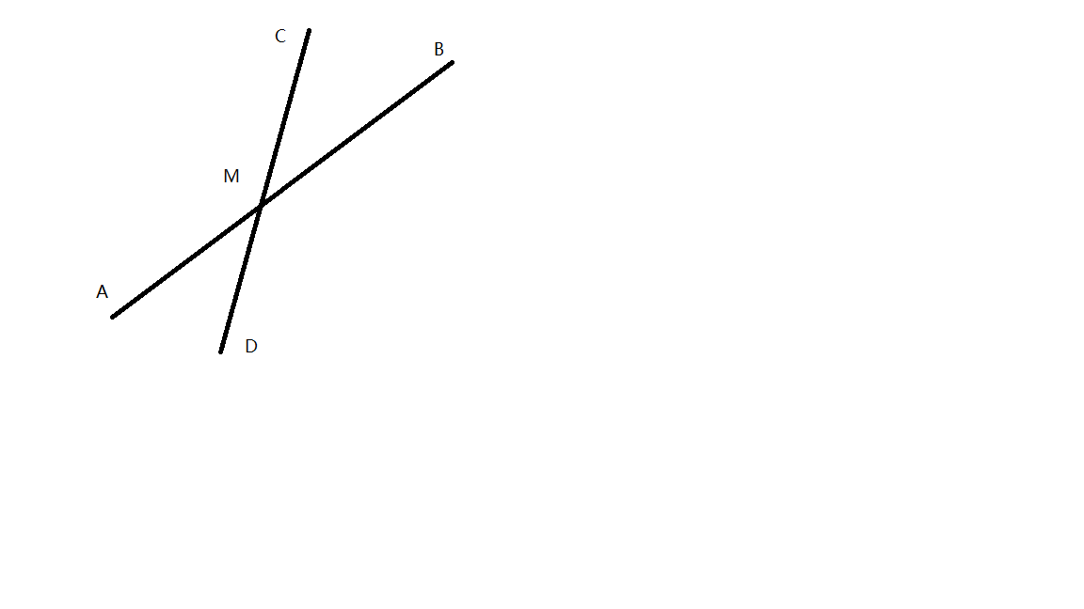代码量大/精度误差/边界情况

1. 直线相交

AB 交 CD，求交点 M坐标

Suppose A(x1,y1)

B(x2,y2)

C(x3,y3)

D(x4,y4)

M is on AB

M can be shown as ,and M is on CD

,and we have 

Thus 

(AB cannot be parallel to CD)